We are a Lighthouse Congregation, committed to offering safety and stability to United Methodists who have been displaced or wounded through disaffiliation.

Colington United Methodist Church

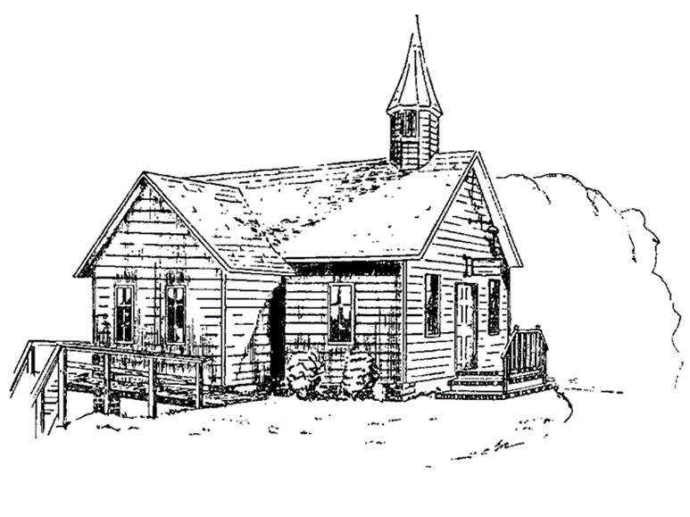

October 12, 2025
United Women in Faith Sunday

ENTRANCE
welcome and announcements
centering
prelude and lighting of altar candles
We Are An Offering Liles/Hayes
call to worship
Bless our God, all you people! Let God’s praise ring out in this place!
God has kept our coming and going. God has not let our feet slip.
Even when we carry heavy burdens on our backs, even through fire and water,
God has been with us. God leads us out to a spacious place.
Come and listen, all who fear God, and we will tell what God has done.
Blessed be God! God hears our prayers. God’s
steadfast love remains always.
introit
Your Love Compels Me Holk
†opening hymn
We Are Called to Be God’s People ǀ Insert
sharing joys and concerns
call to prayer
prayers of the people
PROCLAMATION
the first lesson
2 Timothy 2:8-15
anthem
Lord, Here Am I F. Crosby
the second lesson
Luke 17:11-19
united women in faith
Living Out Our Faith
RESPONSE
†affirmation of praise
Find Us Faithful ǀ Insert
offertory prayer
Loving God, thank you for all that you have provided and all that you will provide. Receive these offerings as signs of our gratitude and expressions of our faith. Holy Spirit, guide us as we continue to faithfully share your love with people near and far. In the name of
Jesus. Amen.
†doxology
Praise God, from Whom All Blessings Flow ǀ UMH 95
recognitions
†closing hymn
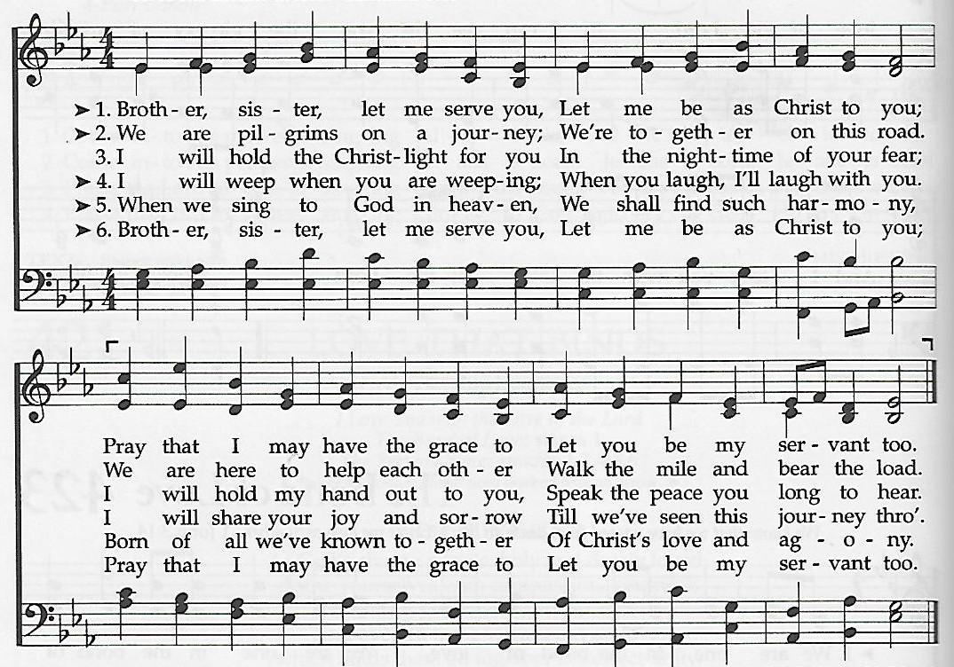
The Servant Song

†benediction
Shalom to You ǀ UMH 666
**The Father, Son and Holy Spirit have certainly tested our little church’s patience, strength and endurance these past 2 week’s with the bad weather that postponed our yard sale, then moved it up……but we succeeded. Thank you to EVERYONE who helped in anyway to make it happen!!

this week at colington
These opportunities to serve as the Body of Christ are available.
Tuesday – 9 am – Prayer Group
Wednesday – 10am – PCP meeting followed by Admin. Council meeting
Thursday – 7:30am – FCA breakfast at FFMS.
Saturday - 9am – Men’s ministry breakfast meeting.

coming up
Next Sunday – 8:15 – choir practice
9:30 am – Worship, in-person and Facebook Live
Wed., Oct. 22 – 10am – Knitters and crocheters meeting. Sat., Oct. 25 – 9:30-11:30 am – UWIF Beacon District Annual meeting at Ware’s Chapel UMC.
Sun., Oct. 26 – 3-4pm – Deb Kasten’s music student’s recital at church.
Fri., Oct. 31 – 7:30am – Student of the month at FFES.

Thanks to today’s volunteers!
Ushers – Cap Pfeiffer/ Steve Knowles

The flowers on the altar are given by the SPRC in recognition of Pastor Appreciation Sunday. “Thank you Pastor Jack for ALL that you do.”

Last week’s attendance – 72.

