We are a Lighthouse Congregation, committed to offering safety and stability to United Methodists who have been displaced or wounded through disaffiliation.

Colington United Methodist Church



October 26, 2025
Reformation Sunday

ENTRANCE
welcome and announcements
centering
prelude and lighting of altar candles
I Love Thy Kingdom, Lord Williams/Labenske
call to worship
The hour is coming, and now is,
when true worshipers will worship the Father
in spirit and truth,
for such the Father seeks to worship him.
Enter his gates with thanksgiving,
and his courts with praise!
Give thanks to him, bless his name!
introit
My Tribute Crouch
opening prayer
Almighty God, whose Son Jesus Christ came to cast fire upon the earth: Grant that by the prayers of your faithful people a fire of burning zeal may be kindled and pass from heart to heart, that the light of your Church may shine forth bright and clear. We ask in the name of
Christ. Amen.
†opening hymn
A Mighty Fortress Is Our God ǀ UMH 110
sharing joys and concerns
prayers of the people
PROCLAMATION
the psalter
Psalm 65
anthem
In Christ Alone
the old testament
Joel 2:23-32
sermon
“Harvesttime” ǀ Rev. Jack Colenda
RESPONSE
†affirmation of praise
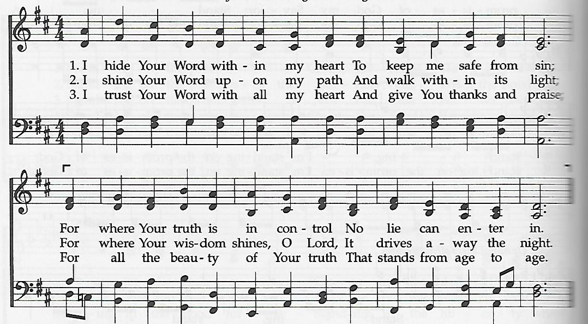
I Hide Your Word Within My Heart

offertory prayer
†doxology
Praise God, from Whom All Blessings Flow ǀ UMH 95
†closing hymn
To God Be the Glory ǀ UMH 98
†benediction
Shalom to You ǀ UMH 666
_________________________________________
this week at colington
These opportunities to serve as the Body of Christ are available.
Today – 3-4pm -Deb Kasten’s music students’ recital.
Tuesday – 9 am – Prayer Group
Friday – 7:30am – Student of the month at FFES.

coming up
Next Sunday – 8:15 – choir practice
9:30 am – Worship, in-person and Facebook Live
Mon., Nov.3 – 1:45pm – MAT at FFES. Contact Gail Hendricks or Ann Trapani to volunteer.
Wed., Nov. 5 – 12pm – Men’s ministry lunch at Spring Arbor
Sat., Nov. 8 – 9am – UWIF breakfast meeting.
Wed., Nov. 12 – 7:30am – FFHS FCA breakfast.
Knitters and crocheters meet.
Thurs., Nov.13 – 4pm – Mobile food pantry at FFES.
Thanks to today’s volunteers!
Ushers – Steve Knowles/ Ozzie Gray
Scripture Reader – Merinda DeHart
The flowers on the altar are given by Merinda DeHart in memory of her husband Jack’s birthday and by Jeff Albarty in memory of his wife Sandy.

Last week’s attendance – 50.

