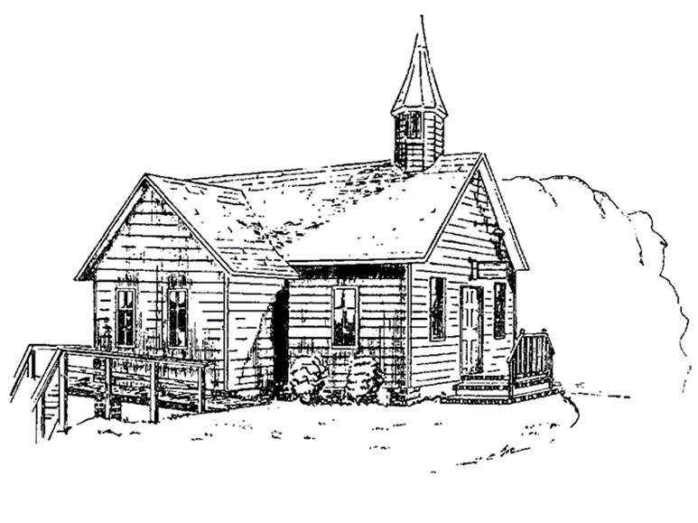
Colington United Methodist Church
We are a Lighthouse Congregation, committed to offering safety and stability to United Methodists who have been displaced or wounded through disaffiliation.

October 5, 2025
World Communion Sunday

ENTRANCE
welcome and announcements
invitation
prelude and lighting of altar candles
He Keeps Me Singing Bridges/Berry
invocation
introit
My Faith Still Holds Gaither
opening prayer
As we gather at your table from all over the world, O God, we pray that all those who come to you in the name of Christ might be one in Spirit. Knead us together in one loaf. Free us from jealousy and selfish ambition; unite us in mission and service to those in need everywhere. May we sow righteousness and harvest peace, through the grace of
Jesus Christ. Amen.
†opening hymn
Holy, Holy, Holy ǀ UMH 64
sharing joys and concerns
call to prayer
prayers of the people
PROCLAMATION
the first lesson
Lamentations 3:19-26
anthem
Let Us Be Bread T. Porter
the second lesson
Habakkuk 1:1-4, 2:1-4
sermon
“There Is Still a Vision” ǀ Rev. Jack Colenda
†affirmation of praise
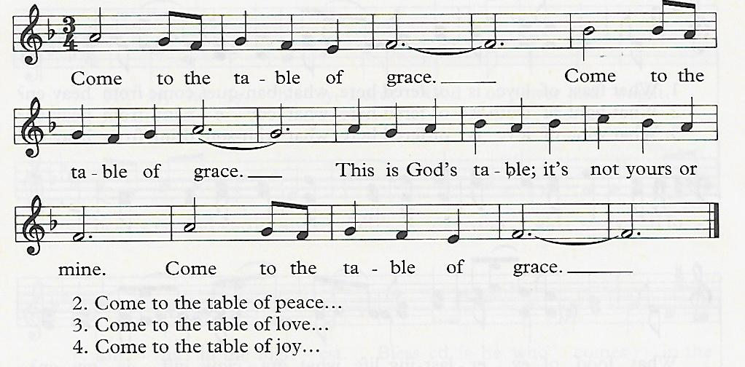
Come to the Table of Grace B. Hamm

†the apostles’ creed ǀ UMH 881
a multilingual prayer
call to communion
We dare not come to this table trusting in our own goodness and virtue.
We come knowing we need forgiveness and trusting God to grant it.
We come because we are hungry for meaning and need to be fed.
God, forgive and feed us.
We come because Jesus Christ invited us.
We come as Christ’s guests to the heavenly banquet.
We come in remembrance, but much more; in recalling the sacrifice of Christ for us we are moved to Christ-like identification with suffering humanity.
We join here not in passive recollection of ancient signs, but in active
reflection of the flesh and blood realities which these signs represent.
†doxology
Praise God, from Whom All Blessings Flow ǀ UMH 95
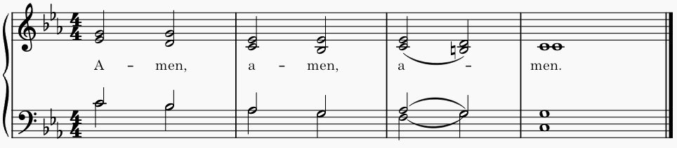
the great thanksgiving ǀ UMH 13

giving the bread and cup
SENDING FORTH
†closing hymn
For the Beauty of the Earth ǀ UMH 92

†benediction
Shalom to You ǀ UMH 666

this week at colington
These opportunities to serve as the Body of Christ are available.
Monday thru Friday – 9am-til – Set-up and prep for church fall yard sale. Lunches will be provided.
Tuesday – 9 am – Prayer Group
Wednesday – 7:30am - FCA breakfast at FFHS.
Knitters and crocheters meeting.
Thursday – 4pm – Mobile food pantry at FFES.
Saturday – 7am – Fall yard sale! Clean-up at 12pm-til.

coming up
Next Sunday – 8:15 – choir practice
9:30 am – Worship, in-person and Facebook Live
Wed., Oct. 15 – 10am – PCP meeting followed by Admin. Council meeting
Thurs., Oct. 16 – 7:30am – FCA breakfast at FFMS.
Sat., Oct. 18 - 9am – Men’s ministry breakfast meeting.
Wed., Oct. 22 – 10am – Knitters and crocheters meeting.
Sat., Oct. 25 – 9:30-11:30 am – UWIF Beacon District Annual meeting at Ware’s Chapel UMC.
Sun., Oct. 26 – 3-4pm – Deb Kasten’s music student’s recital at church.
Fri., Oct. 31 – 7:30am – Student of the month at FFES.

Thanks to today’s volunteers!
Ushers – Steve Knowles/ Ozzie Gray
Scripture Reader – Cathy Merritt
Communion Assistant – Stacy Murphy

The flowers on the altar are given by Sherry Rollason celebrating Bill Sport’s birthday!

Last week’s attendance – 64.

