

Colington United Methodist Church

December 14, 2025
The Third Sunday of Advent

WEEK THREE: THE GIFT OF MUSIC FOR PRAISE
welcome and announcements
centering
prelude and lighting of altar candles
Joy Has Dawned Getty/Townsend
call to worship
See! The ruler of earth shall come,
the Lord who will take from us the heavy burden
of our exile.
The hills and the mountains will be singing
praise to God.
Every tree in the forest will be clapping its hands.
The Lord will come and rule for ever. Alleluia.
introit
Make Music for the Lord N. Sleeth
†opening hymn
Hark! the Herald Angels Sing ǀ UMH 240
the old testament
Isaiah 35:1-10
anthem
Christmas Grace Schram
the gospel
Luke 1:46-55
sermon
“When In Doubt, Write a Hymn” ǀ Rev. Jack Colenda
affirmation of praise
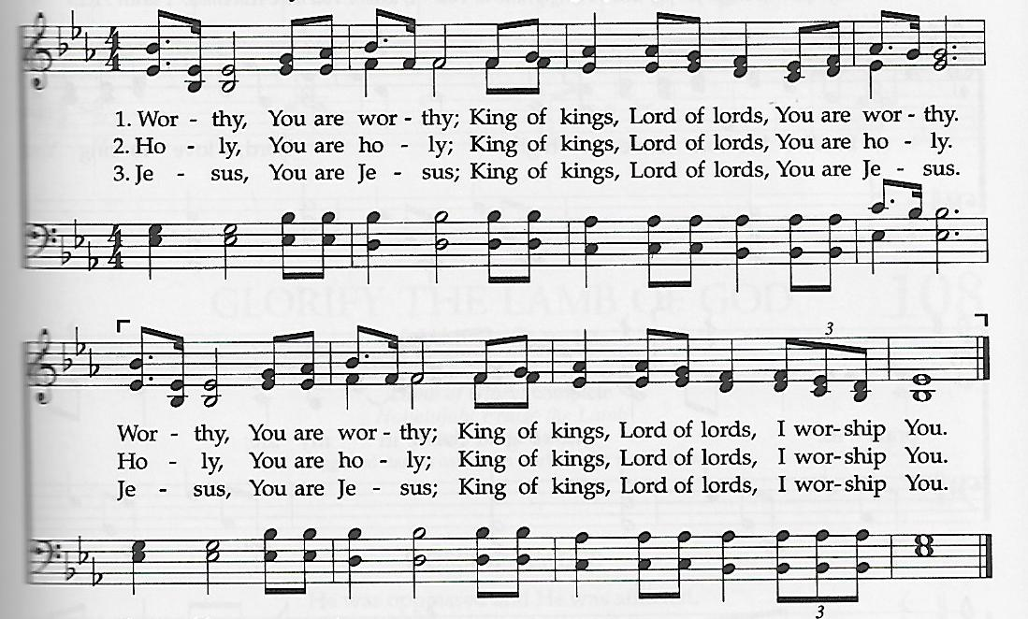
Worthy, You Are Worthy

prayers of the people
anthem
Sing With the Angels Gray
prayer of thanksgiving
†closing hymn
Angels We Have Heard on High ǀ UMH 238
†benediction (to sing we now of christmas)
Go in peace, Beloved, Bless you now, my friends.
Bear the light of Jesus, love that never ends.
Wait for your God: for patience is our call.
Christ is coming soon now! Love and joy to all!
_______________________________________________
this week at colington
These opportunities to serve as the Body of Christ are available.

Monday – 2:15pm – MAT at FFES.
Tuesday – 9 am – Prayer Group
Wednesday – 10am – PCP meeting and Admin Council to follow.
Thursday – 7:30am - FFMS FCA breakfast.
Friday – 7:30am – Student of the month at FFES.
Saturday – 9am – Men’s ministry breakfast meeting.

coming up
Next Sunday – 8:15 – choir practice
9:30 am – Worship, in-person and Facebook Live
Wed., Dec. 24 – 5pm – Christmas Eve Candlelight Service
Thurs., Dec. 25 – Jesus Christ is born!! Merry Christmas!!

**Alphabetized baskets are now placed in Fellowship Hall for intra-church Christmas Cards again this year. Save-a-Stamp.

Thanks to today’s volunteers!
Ushers – Steve Knowles/ Rick Hildebrant
Scripture Reader – Joan Daniels
The poinsettias on the altar are given to the Glory of God.

A Note from the Staff
We are grateful for you, our church family, in this holiday season and all the year long. It is a joy to be in ministry with you. Thank you for your love, support, and generosity. We truly appreciate the Christmas bonuses, and wish the rich blessings of the season upon all of you.
Ronda, Sue, and Jack

