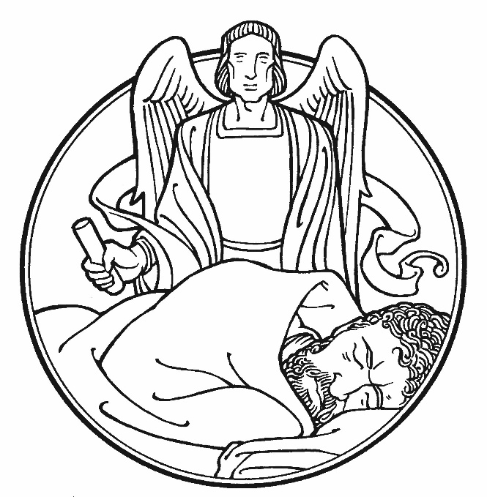
Colington United Methodist Church

December 21, 2025
The Fourth Sunday of Advent

WEEK FOUR: THE GIFT OF OPPORTUNITIES FOR SERVICE
welcome and announcements
centering
prelude and lighting of altar candles
I Wonder as I Wander Niles/Labenske
opening prayer
introit
What Can I Give Him
†opening hymn
Come, Thou Long-Expected Jesus ǀ UMH 196
the epistle
Romans 1:1-7
anthem
I’ll Be a Shepherd Coleman
the gospel
Matthew 1:18-25
sermon
“Promised Possession” ǀ Rev. Jack Colenda
affirmation of praise
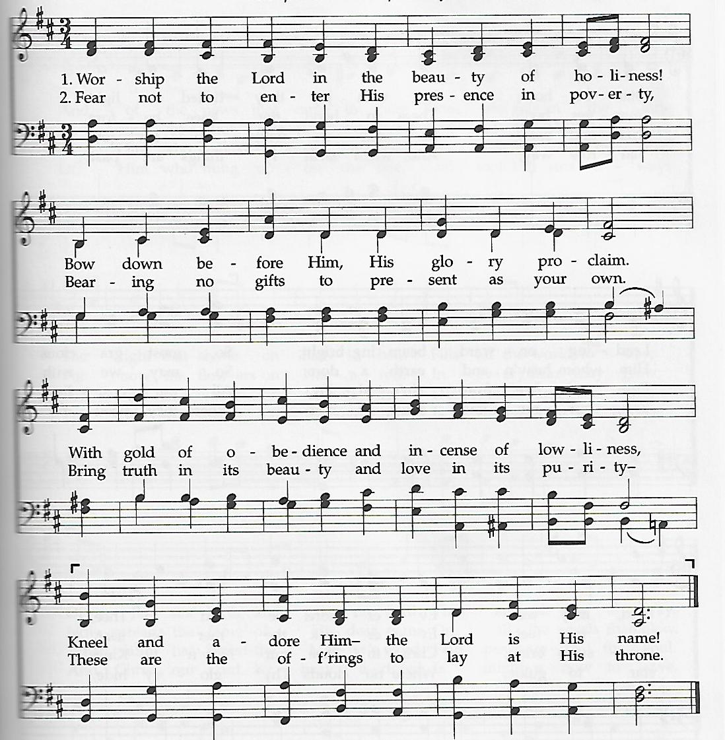
Adoration

prayers of the people
the great thanksgiving
anthem
May I Shine His Light Allred
giving the bread and cup
†closing hymn
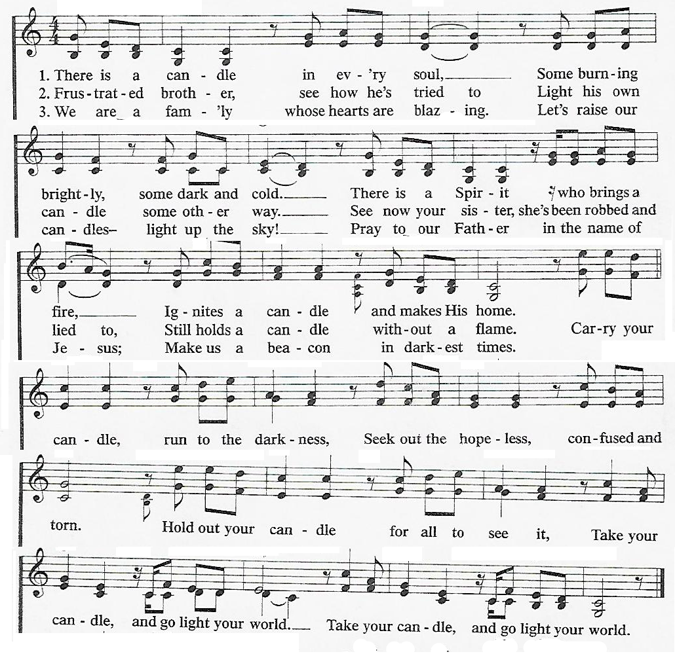
Go Light Your World Rice

†benediction (to sing we now of christmas)
Go in peace, Beloved, Bless you now, my friends.
Bear the light of Jesus, love that never ends.
Wait for your God: for patience is our call.
Christ is coming soon now! Love and joy to all!
_______________________________________________
this week at colington
These opportunities to serve as the Body of Christ are available.

Tuesday – 9 am – Prayer Group
Wednesday – 5pm – Christmas Eve Candlelight Service
Thursday – Jesus Christ is born!! Merry Christmas!!

*Please check the alphabetized Christmas card containers on the counter in the fellowship room.

coming up
Next Sunday – NO choir practice
9:30 am – Worship, in-person and Facebook Live

Thanks to today’s volunteers!
Ushers – Steve Knowles/ Ozzie Gray
Scripture Reader – Sherry Rollason
Communion Assistant – Stacy Murphy

The poinsettias on the altar are given to the Glory of God.

Last week’s attendance – 60.

