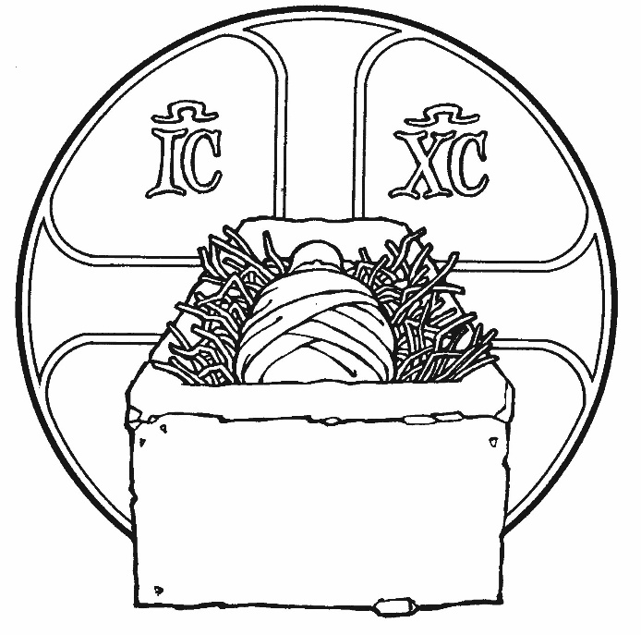
Colington United Methodist Church

December 7, 2025
The Second Sunday in Advent

WEEK TWO: THE GIFT OF A BABY FOR SALVATION
centering
prelude and lighting of altar candles
Lo, How a Rose E’er Blooming Arr. B. Johnson
call to worship
Heavens be glad, and earth rejoice!
For God comes in power to judge the earth.
We open our hearts in worship and trust.
We offer our lives in willing service.
For God shall bring righteousness, truth, and peace.
Come, Lord Jesus.
introit
Let Us Adore Him Parks
†opening hymn
O Come, O Come, Emmanuel ǀ UMH 221
prayers of the people
the epistle
Romans 15:4-13
anthem
God’s Gift to Us
the old testament
Isaiah 11:1-10
sermon
“When Jesse’s Shoot Appears” ǀ Rev. Jack Colenda
anthem
Welcome, Lord Jesus
the great thanksgiving ǀ UMH 15
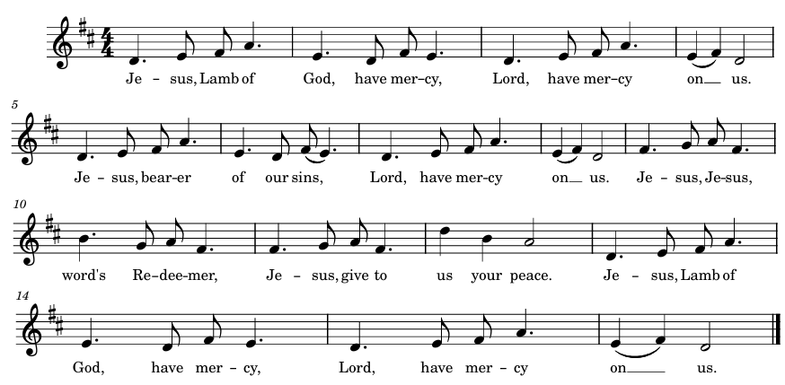
fraction hymn Harvey/Welsh Traditional

giving the bread and cup
special music
Like a Child ǀ Becky Eanet
†closing hymn
O Little Town of Bethlehem ǀ UMH 230
†benediction (to sing we now of christmas)
Go in peace, Beloved, Bless you now, my friends.
Bear the light of Jesus, love that never ends.
Wait for your God: for patience is our call.
Christ is coming soon now! Love and joy to all!
_______________________________________________
this week at colington
These opportunities to serve as the Body of Christ are available.

Monday – 2:15pm – MAT at FFES.
Tuesday – 9 am – Prayer Group
Wed., Dec. 10 – 7:30am – FFHS FCA breakfast.
10am – Knitters and crocheters meet.
Thurs., Dec. 11 –Cookies for MFP should be at church by 10am today. Please label if they contain nuts. Contact Jo Briggs at 919-801-0330 for questions. 4pm – Mobile food pantry at FFES.
Sat., Dec. 13 – 9am – UWIF breakfast meeting at church and zoomed.

coming up
Next Sunday – 8:15 – choir practice
9:30 am – Worship, in-person and Facebook Live
Wed., Dec. 17 – 10am – PCP meeting and Admin Council to follow.
Thurs., Dec. 18 – 7:30am - FFMS FCA breakfast.
Fri., Dec. 19 – 7:30am – Student of the month at FFES.
Sat., Dec. 20 – 9am – Men’s ministry breakfast meeting.
Wed., Dec. 24 – 5pm – Christmas Eve Candlelight Service

**Alphabetized baskets will be placed in Fellowship Hall for intra-church Christmas Cards again this year. Save-a-Stamp.
Thanks to today’s volunteers!
Ushers – Steve Knowles/ Ozzie Gray
Scripture Reader – Sherry Rollason
Communion Assistant – Temple Heggie

The poinsettias on the altar are given to the Glory of God.

