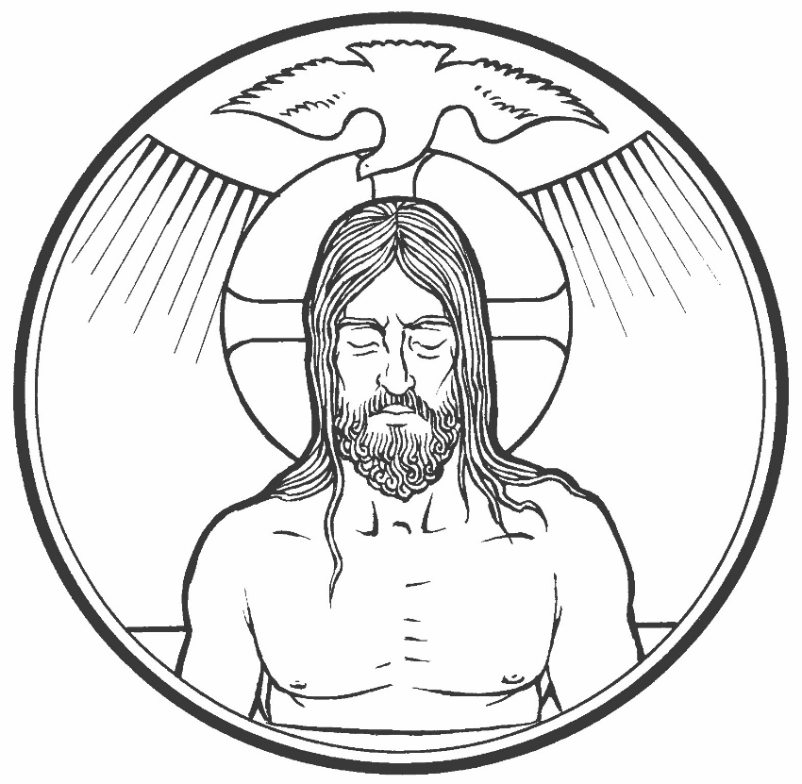
Colington United Methodist Church
January 11, 2026
Baptism of the Lord

welcome and announcements
centering
prelude and lighting of altar candles
Make Us Holy, Make Us Whole Friedman/Vogt
call to worship
By Word and water God renews us this day in the living
fountain of God’s grace
and raises us with Christ Jesus to live a new life in the Spirit.
Remember your baptism and be thankful!
introit
Into My Heart
opening prayer
Living God, when the Spirit descended on Jesus at his baptism in Jordan’s water you revealed him as your own beloved Son. You anointed him with the Holy Spirit. Grant that all who are baptized into his name may keep the covenant they have made, and boldly confess Jesus Christ as Lord and Savior now and for ever. Amen.
†opening hymn
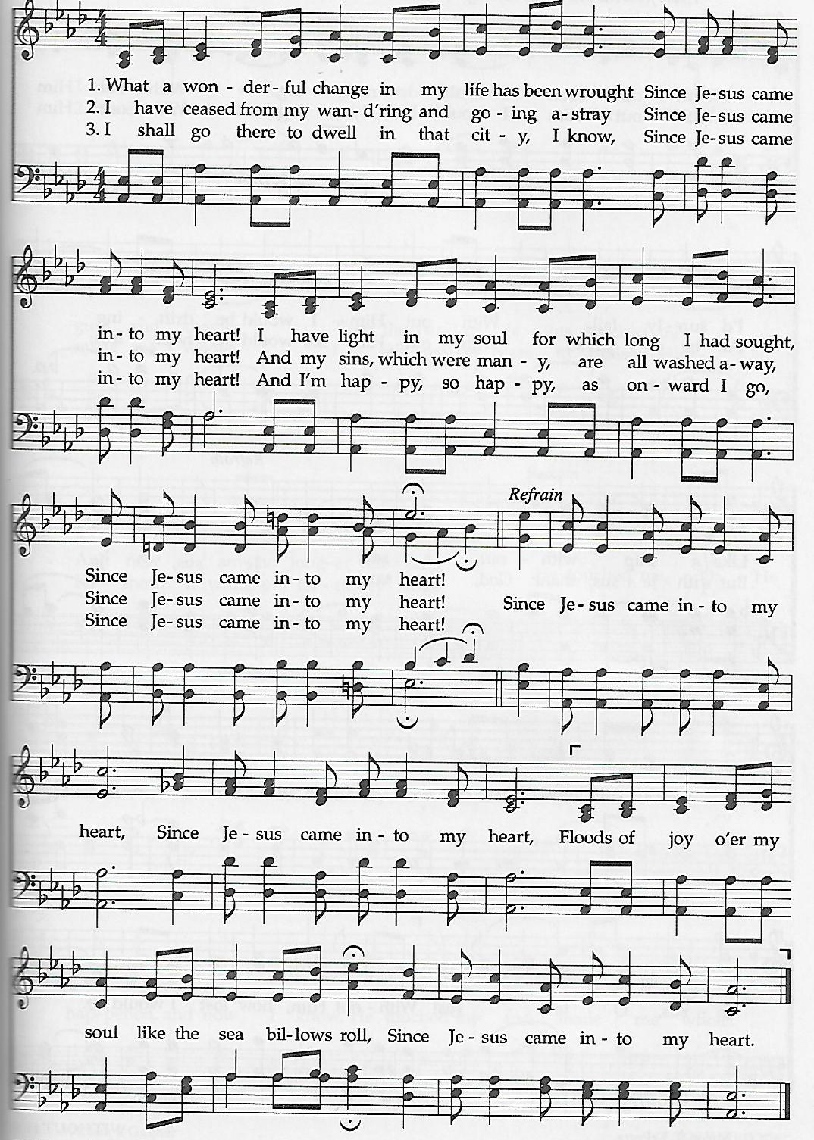
Since Jesus Came into My Heart

the prayers of the people
the old testament
Isaiah 42:1-9
the gospel
Matthew 3:13-17
hymn of preparation
Have Thine Own Way, Lord ǀ UMH 372
sermon
“Sign Me Up” ǀ Rev. Jack Colenda
†affirmation of praise
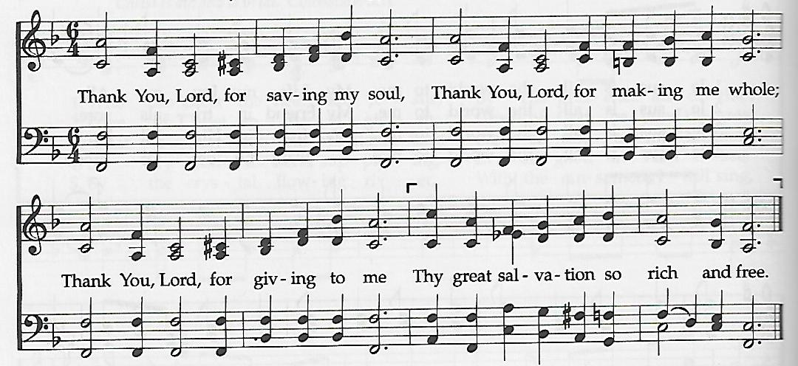
Thank You, Lord

prayer of thanksgiving
doxology
Praise God, from Whom All Blessings Flow ǀ UMH 95
reaffirmation of the marriage covenant
†closing hymn
Let There Be Peace on Earth ǀ UMH 431

†benediction
God Be with You till We Meet Again (vs. 2) ǀ UMH 673
this week at colington
These opportunities to serve as the Body of Christ are available.
Tuesday – 9 am – Prayer Group
Sunday - Saturday – Hosting dinners for RITI. Sign-up sheet in fellowship room.
Monday – 2:15pm – MAT restarts at FFES.
Wednesday – 7:30am – FFHS FCA breakfast.
10am – Knitters and crocheters
6pm – Paint Party in fellowship room. Sign-up at www.happyartpaintparty.com.
Thursday - 7:30am - FFMS FCA breakfast.
Saturday – 9am – Men’s ministry breakfast meeting.

coming up
Next Sunday – 8:15 – choir practice
9:30 am – Worship, in-person and Facebook Live
Wed., Jan. 28 – 10am – Knitters and crocheters
1:45pm – Volunteers to Beach Food Pantry.
Fri., Jan. 30 – 7:30am – Student of the month at FFES.

Thanks to today’s volunteers!
Ushers – Steve Knowles/ Ozzie Gray
Scripture Reader – Pat Hansen
The flowers on the altar are given by Rick Hildebrant.

Last week’s attendance – 63.

