
Colington United Methodist Church
January 18, 2026
Second Sunday after the Epiphany

welcome and announcements
centering
prelude and lighting of altar candles
We Are an Offering
call to worship
introit
Here I Am to Worship
opening prayer
†opening medley
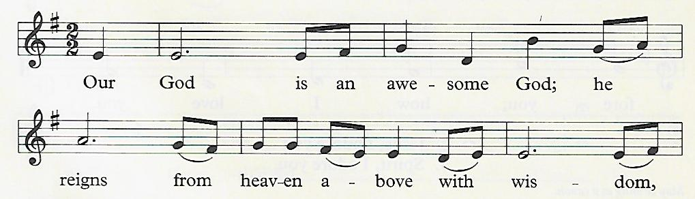
Awesome God

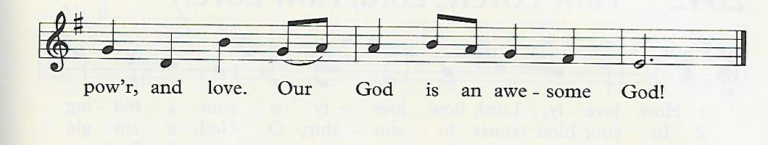
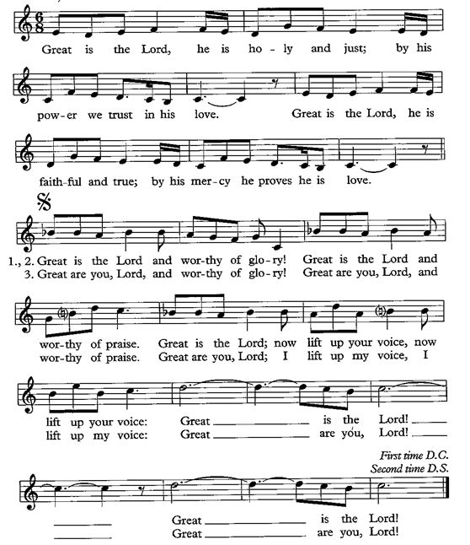
Great Is the Lord

How Great Thou Art (Chorus)…Then sings my soul, my Savior, God to thee
the prayers of the people
the epistle
1 Corinthians 1:1-9
the gospel
John 1:29-42
sermon
“Thank You Note” ǀ Rev. Jack Colenda
†affirmation of praise
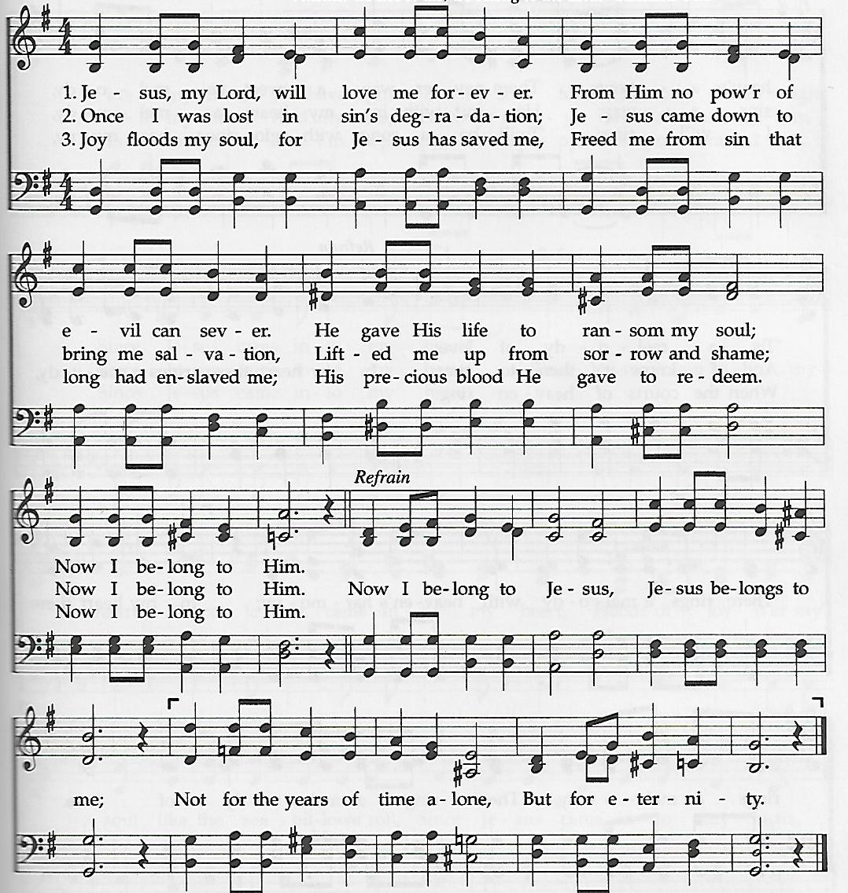
Now I Belong to Jesus

hymns by request
holy communion
†closing hymn
Precious Name ǀ UMH 536

†benediction
God Be with You till We Meet Again (vs. 3) ǀ UMH 673

this week at colington
These opportunities to serve as the Body of Christ are available.
Monday – 2:15pm – MAT at FFES
Tuesday – 9 am – Prayer Group

**Sending out a special “THANK YOU” to those who prepared dinners last week for RITI guests and much appreciation to everyone who donated money, making it possible to fill 2 car trunks full of supplies and groceries that were delivered to RITI!

coming up
Next Sunday – 8:15 – choir practice
9:30 am – Worship, in-person and Facebook Live
Wed., Jan. 28 – 10am – Knitters and crocheters
1:45pm – Volunteers to Beach Food Pantry.
Fri., Jan. 30 – 7:30am – Student of the month at FFES.

Thanks to today’s volunteers!
Ushers – Ozzie Gray/ Steve Knowles
Scripture Reader – Trish Gray
The flowers on the altar are given to the Glory of God.

Last week’s attendance – 60.

