
Colington United Methodist Church
January 4, 2026
Feast of the Epiphany

welcome and announcements
centering
prelude and lighting of altar candles
One Small Child
call to worship
All the ends of the earth have seen the salvation of our God, Alleluia!
Shout to the Lord, all the earth, Alleluia!
The grace of God has dawned upon the world
with healing for all humankind.
introit
Holy Savior
opening prayer
Everlasting God, the radiance of faithful souls, you brought the nations to your light and kings to the brightness of your rising. Fill the world with your glory, and show yourself to all the nations; through him who is the true light and the bright and morning star, even Jesus Christ your Son our Lord. Amen.
†opening hymn
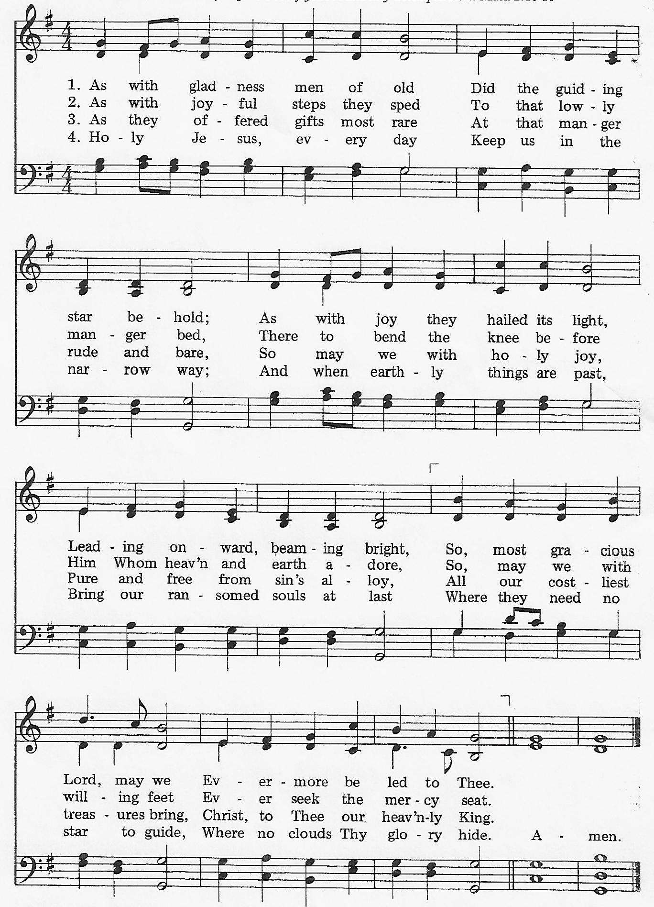
As with Gladness Men of Old

the old testament
Isaiah 60:1-6
anthem
If I Could Visit Bethlehem
the new testament
Ephesians 3:1-12
sermon
“Epiphany” ǀ Rev. Jack Colenda
†affirmation of praise
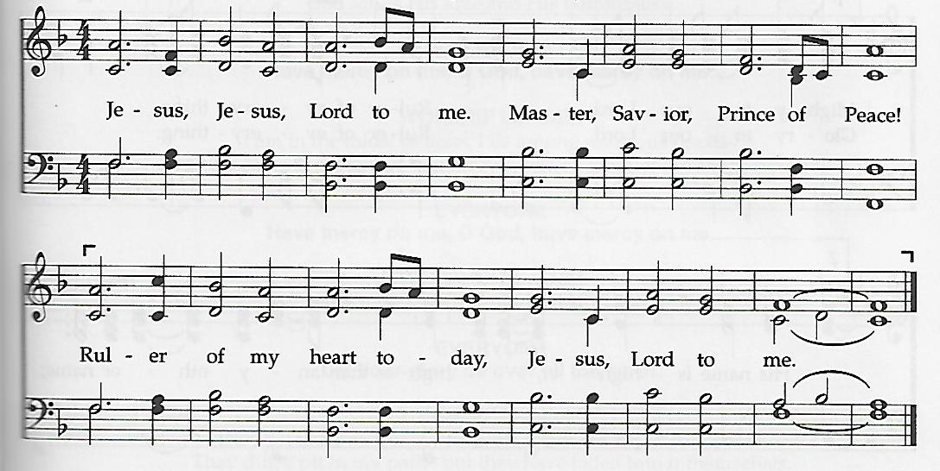
Jesus, Lord to Me

the prayers of the people
doxology
Praise God, from Whom All Blessings Flow ǀ UMH 95
the great thanksgiving ǀ UMH 23
†closing hymn
We Three Kings ǀ UMH 254

†benediction
God Be with You till We Meet Again (vs. 1) ǀ UMH 673
this week at colington
These opportunities to serve as the Body of Christ are available.
Tuesday – 9 am – Prayer Group
Wednesday – 12pm – Men’s ministry lunch at Spring Arbor.
Thursday – 4pm - Mobile food pantry at FFES.
Saturday – 9am – UWIF breakfast meeting.

coming up
Next Sunday – 8:15 – choir practice
9:30 am – Worship, in-person and on Facebook Live
Sun., Jan. 11 - Sat., Jan. 17 – Hosting dinners for RITI. Sign-up sheet in fellowship room.
Mon., Jan. 12 – 2:15pm – MAT restarts at FFES.
Wed., Jan. 14 – 7:30am – FFHS FCA breakfast.
10am – Knitters and crocheters
6pm – Paint Party in fellowship room. Sign-up at www.happyartpaintparty.com.
Thurs., Jan. 15 - 7:30am - FFMS FCA breakfast.
Sat., Jan. 17 – 9am – Men’s ministry breakfast meeting.
Wed., Jan. 28 – 10am – Knitters and crocheters
1:45pm – Volunteers to Beach Food Pantry.
Fri., Jan. 30 – 7:30am – Student of the month at FFES.

Thanks to today’s volunteers!
Ushers – Steve Knowles/ Ozzie Gray
Scripture Reader – Ozzie Gray
Communion Assistant – Anne Trapani

The poinsettias on the altar are given to the Glory of God.

Last week’s attendance – 33.

