Colington United Methodist Church
February 15, 2026
Transfiguration of the Lord
welcome and announcements
centering
prelude and lighting of altar candles
The Power of Your Love Bullock
call to worship
introit
We Have Come to Join In Worship
opening prayer
Lord God, in the transfiguration of your only-begotten Son you confirmed the mysteries of faith by the witness of your prophets, and wonderfully foreshadowed our full adoption as your children. Grant that we, your people, heeding the voice of your beloved Son, may become heirs with him to eternal glory. We ask this through him who lives and
reigns with you and the Holy Spirit, God for ever and ever. Amen.
†opening medley
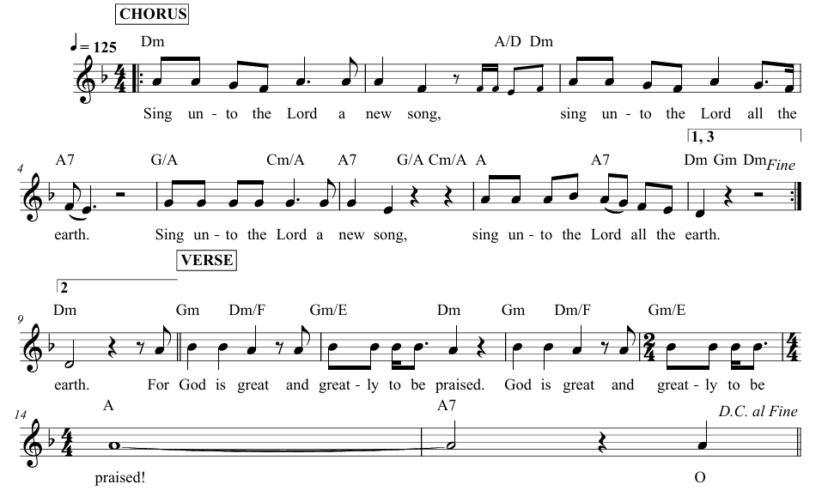
Sing Unto the Lord

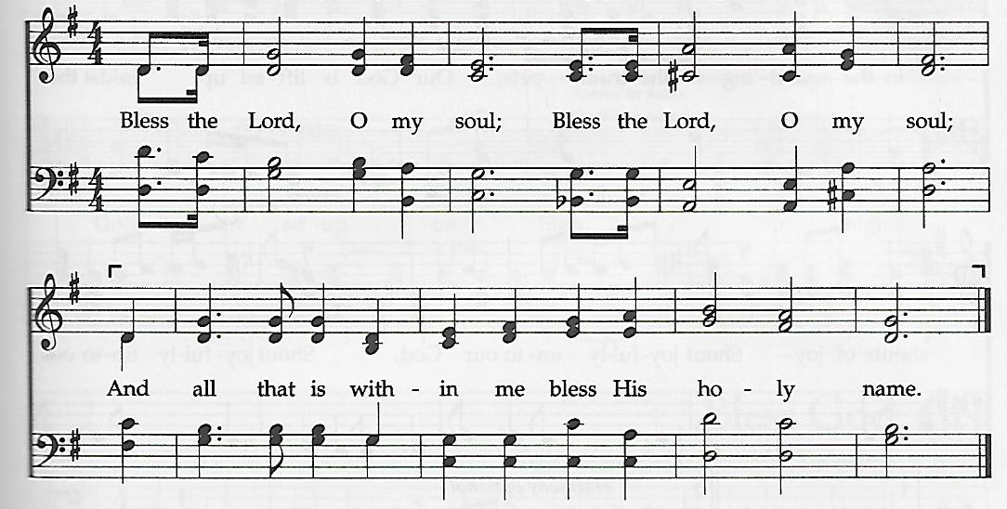
Bless the Lord, O My Soul

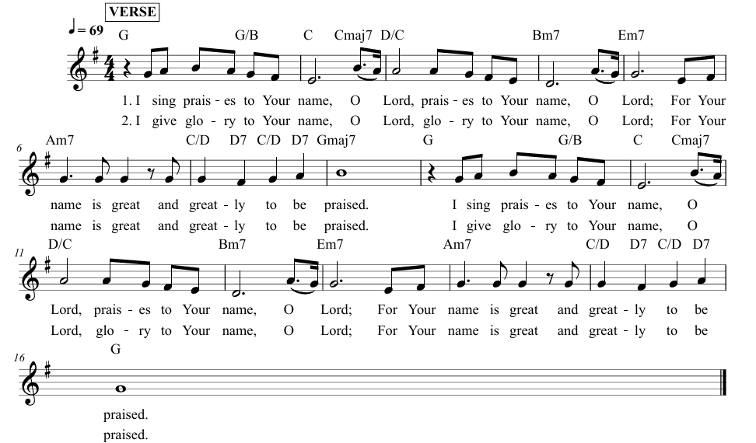
I Sing Praises

the prayers of the people

the old testament
Exodus 24:12-18
anthem
The Lord’s Prayer ǀ Ted Ewald
the gospel
Matthew 17:1-9
sermon
“Up On the Mountain” ǀ Rev. Jack Colenda
†affirmation of praise
Surely the Presence of the Lord ǀ UMH 328
holy communion
sung response – Give Thanks ǀ UMH inside back cover
†closing hymn
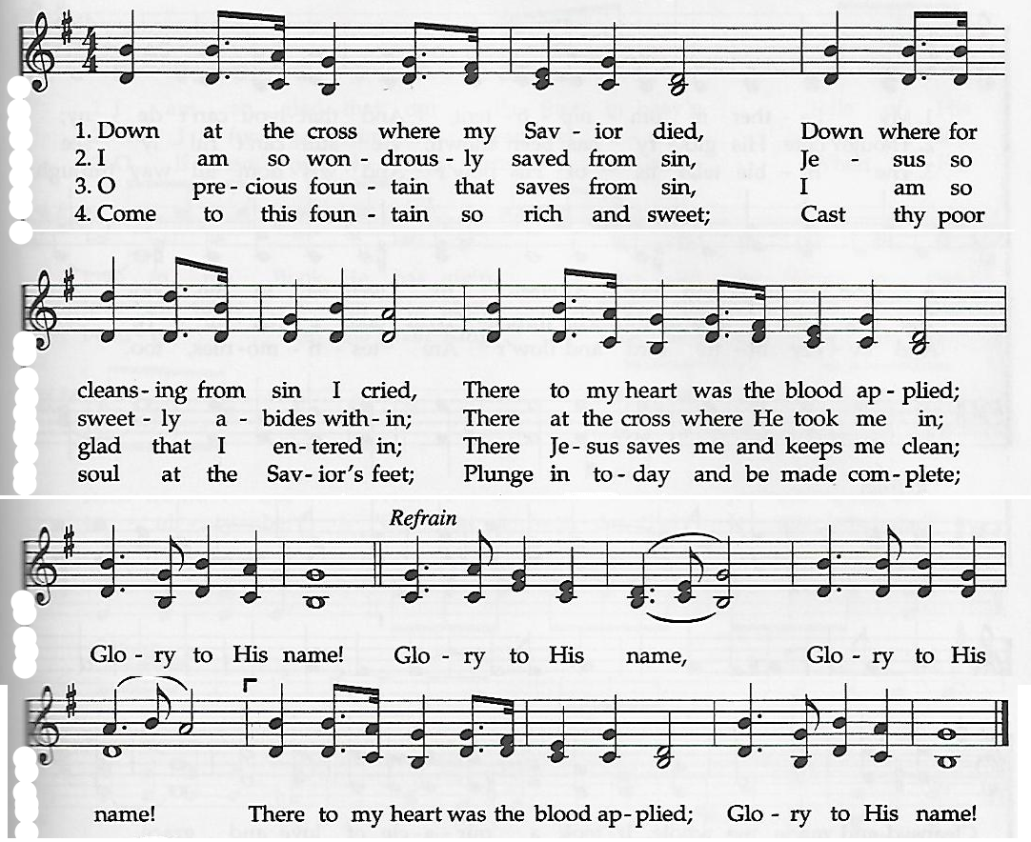
Glory to His Name

this week at colington
These opportunities to serve as the Body of Christ are available.
Tuesday – 9 am – Prayer Group
4:00 – 6:30pm – Shrove Tuesday pancake supper. Eat-in or take-out.
Wednesday – 10am – Administrative Council meeting.
5pm - Ash Wednesday service
Thursday – 7:30am - FCA breakfast at FFMS.
Saturday– 9am – Men’s ministry breakfast meeting.

coming up
Next Sunday – 8:15 – choir practice
9:30 am – Worship, in-person and Facebook Live
Mon., Feb. 23 - 2:45pm – MAT resumes at FFES.
Tues., Feb. 24 – 1:30pm – Bible study at church.
Wed., Feb. 25 – 10am – Knitters and crocheters. 1:45pm – Volunteers to Beach food pantry. 5:30pm – Bible study at church.
Fri., Feb. 27 – 7:30am – Student of the month at FFES.

Thanks to today’s volunteers!
Ushers – Steve Knowles/ Ozzie Gray
Scripture Reader – Pat Hansen
Communion Assistant – Louanne Ewald

The flowers on the altar are given by Becky Eanet in memory of her father, Larry Eanet.

Last week’s attendance – 58.

