Colington United Methodist Church
We are a Lighthouse Congregation, committed to offering safety and stability to United Methodists who have been displaced or wounded through disaffiliation.



February 22, 2026
First Sunday in Lent

welcome and announcements
call to confession
prayer of confession*
Eternal God, from the beginning of time you have called your children into communion with you. Yet we confess that like all the rest, we have turned to our own way and refused your love and grace. Restore us to the joy of knowing you, and of recognizing your reign among us, through Jesus
Christ, bringer of your good news. Amen.
prelude and lighting of altar candles
The Light of the World Is Jesus Hayes/Bliss
call to worship
Bless the Lord who forgives all our sins.
His mercy endures for ever.
The Lord is full of compassion and mercy:
Come let us adore him.
introit
The Family of God Gaither
opening prayer
†opening hymn
Jesus Shall Reign ǀ UMH 157
prayers of the people
the first lesson
Psalm 32
anthem
You Are the Light Bible/Fettke
the second lesson
Genesis 2:15-17; 3:1-13
sermon
“Wanted” ǀ Rev. Jack Colenda
affirmation of praise
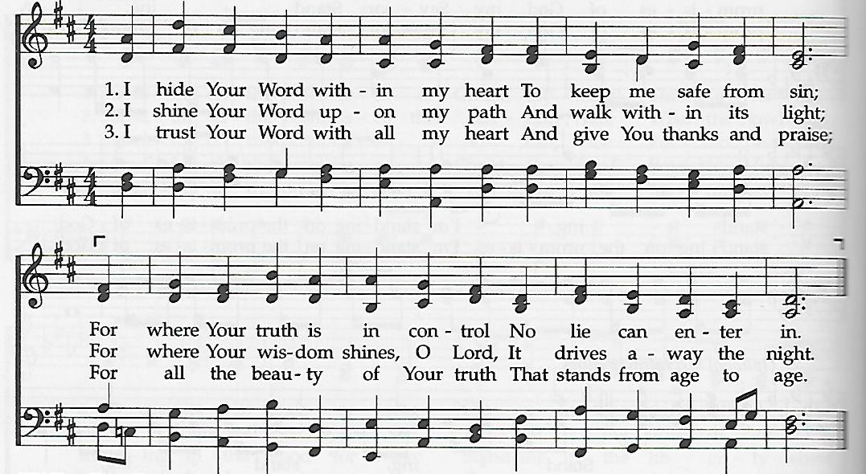
I Hide Your Word Within My Heart

prayer of thanksgiving
†closing hymn
He Leadeth Me ǀ UMH 128
†benediction
*Reprinted by permission of the publisher from Flames of the Spirit, ed. Ruth C. Duck. © 1985 by The Pilgrim Press.

this week at colington
Monday – 2:45pm – MAT at FFES.
Tuesday – 9 am – Prayer Group
1:30pm – Bible study at church.
Wednesday – 10am – Knitters and crocheters. 1:45pm – Volunteers to Beach food pantry. 5:30pm – Bible study at church.
Friday – 7:30am – Student of the month at FFES.
Saturday – 9:00am – Church financial audit.

coming up
Next Sunday – 8:15 – choir practice
9:30 am – Worship, in-person and Facebook Live
Tues., March 3 – 1:30pm – Bible study.
Wed., March 4 – 12pm – Men’s ministry lunch at Spring Arbor. 5:30pm – Bible study.
Tues., March 10 – 1:30pm – Bible study.
Wed., March 11 – 7:30am - FFHS FCA breakfast.
10am – Knitters and crocheters meet.
5:30pm – Bible study
Thurs., March 12 – 4pm - Mobile food pantry- FFES.
Thanks to today’s volunteers!
Ushers – Steve Knowles/ Ozzie Gray
Scripture Reader – Merinda DeHart
The flowers on the altar are given to the Glory of God.

Last week’s attendance – 68.

