
Colington United Methodist Church
March 1, 2026
Second Sunday in Lent

welcome and announcements
centering
prelude and lighting of altar candles
Jesus, the Very Thought of Thee
call to worship
In this season, we worship remembering Jesus’ death in love for us and all people.
Lent is a time of tears.
But out of tears, joy is born – the joy of sin forgiven, hope reborn, and life restored.
Response:
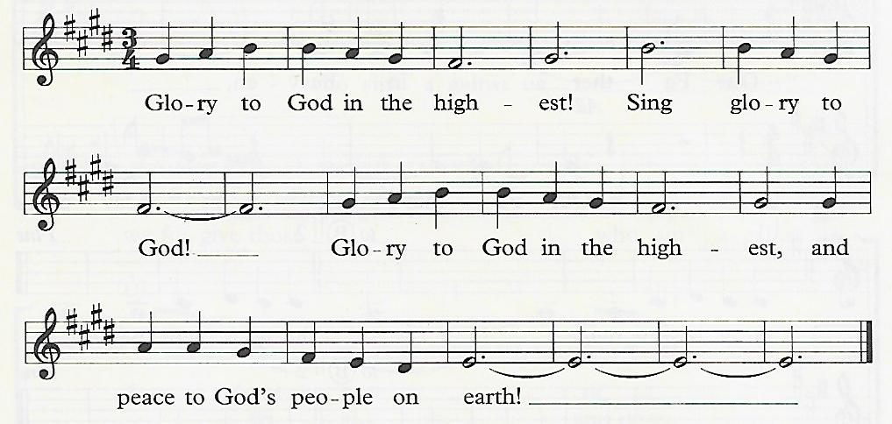

We stand in awe of the God who brings joy out of tears, and life out of death. Let us worship with reverence.
Response
introit
Worthy of Worship
opening prayer
Abraham and Sarah went out, not knowing where they were headed, because they trusted in you. Jesus went forward to his death in Jerusalem, trusting in your purpose. Help us, like them, to take you at your word, and thus to move onward in faith. Be the lamp to our feet,
and the light to our path, through your Spirit of life and wisdom. Amen.
†opening hymn
O For a Thousand Tongues to Sing ǀ UMH 57
the prayers of the people
the first lesson
Genesis 12:1-4
anthem
You Feed Us, Gentle Savior
the second lesson
John 3:1-17
sermon
“When the Wind Blows” ǀ Rev. Jack Colenda
†affirmation of praise
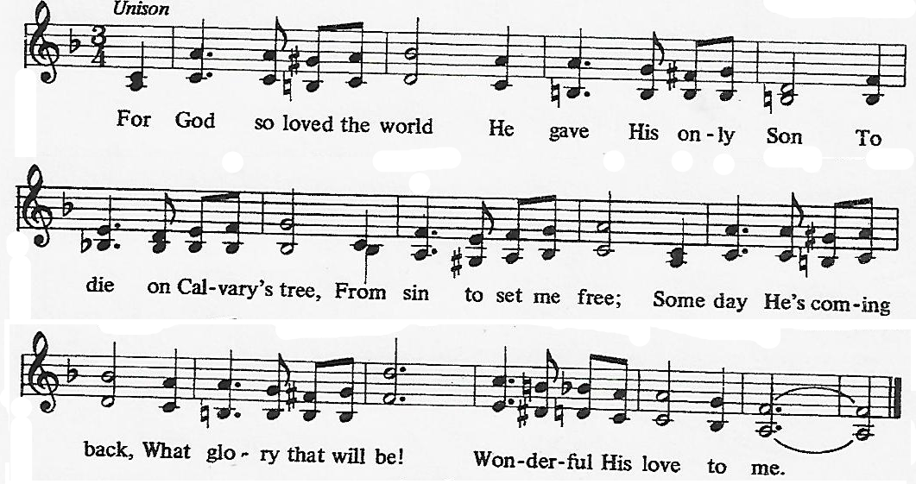
For God So Loved the World

confession and pardon ǀ UMH 26
doxology
Praise God, from Whom All Blessings Flow ǀ UMH 95
the great thanksgiving ǀ UMH 27
†closing hymn
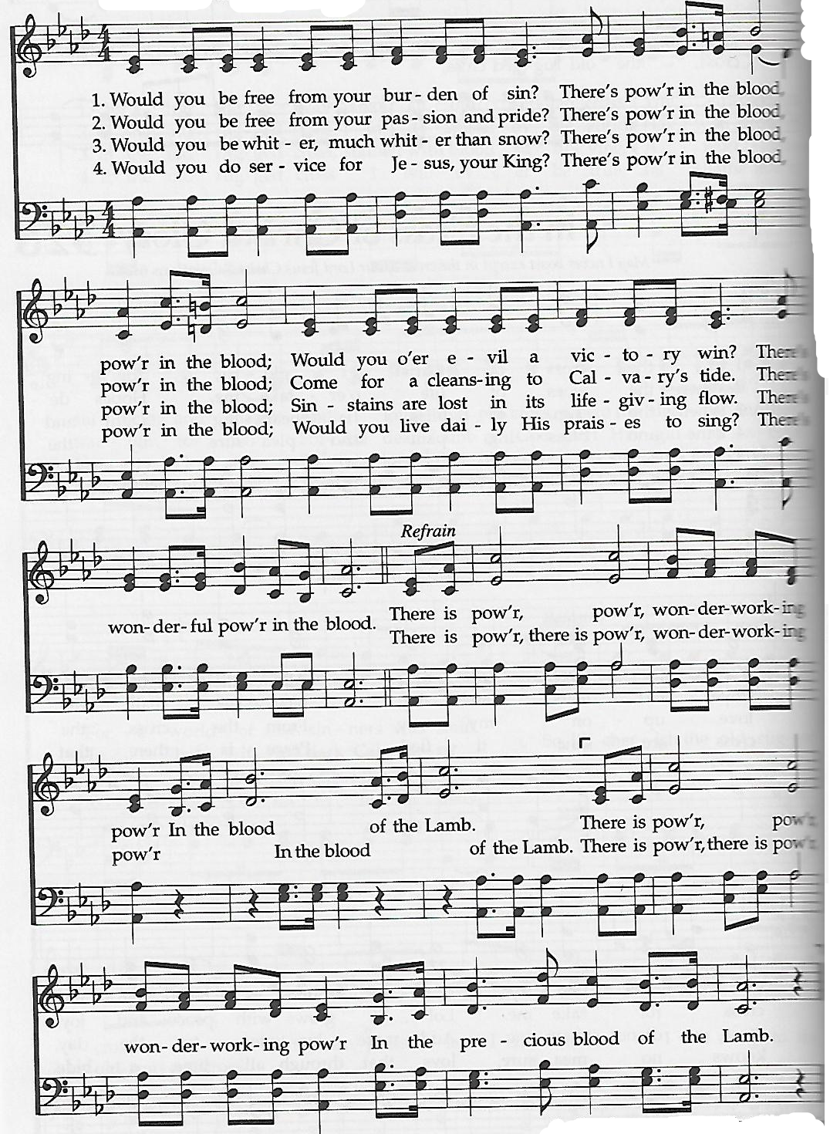
There Is Power in the Blood

this week at colington
These opportunities to serve as the Body of Christ are available.
Tuesday – 9 am – Prayer Group

coming up
Next Sunday – 8:15 – choir practice
9:30 am – Worship, in-person and Facebook Live

Thanks to today’s volunteers!
Ushers –
Scripture Reader –
The flowers on the altar are given by

