
Colington United Methodist Church
March 15, 2026
Fourth Sunday in Lent

welcome and announcements
centering
prelude and lighting of altar candles
More Love to Thee, O Christ
litany
Hear the commandments of God to his people:
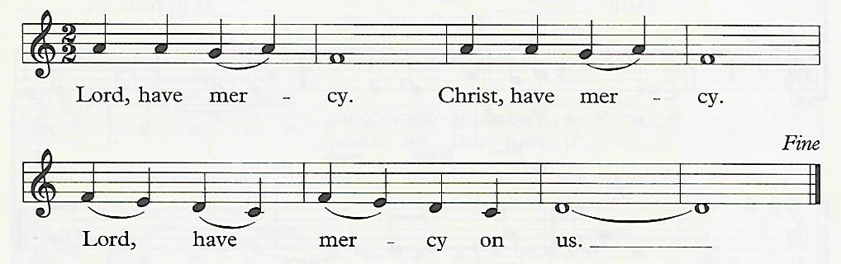
I am the Lord your God who brought you out of bondage. You shall have no other gods but me.

You shall not make for yourself any idol. R
You shall not invoke with malice the Name of the Lord your God. R
Remember the Sabbath day and keep it holy. R
Honor your father and mother. R
You shall not commit murder. R
You shall not commit adultery. R
You shall not steal. R
You shall not be a false witness. R
You shall not covet anything that belongs to your neighbor. R
introit
Open My Eyes, That I May See
call to worship
We have gathered in the presence of God, who is love.
We have gathered in the shadow of the cross, sign of God’s love.
Let us give thanks for the compassion of God, the grace of Jesus Christ, and the unity of the Holy Spirit.
We will pray and sing, praising God with hearts and hands and voices.
Amen.
†opening hymn
God of Grace and God of Glory ǀ UMH 577
the prayers of the people
the first lesson
Ephesians 5:8-14
hymn of preparation
Turn Your Eyes Upon Jesus ǀ UMH 349
the second lesson
John 9:1-41
sermon
“Uninvited, Unexpected, Unbelieved” ǀ Rev. Jack Colenda
special music
Amazing Grace ǀ Selby Cooper, bagpipes
confession and pardon ǀ UMH 890
doxology
Praise God, from Whom All Blessings Flow ǀ UMH 95
†closing hymn
Who Is He in Yonder Stall ǀ UMH 190
benediction

this week at colington
These opportunities to serve as the Body of Christ are available.
Monday – 2:15pm – MAT at FFES.
Tuesday – 9 am – Prayer Group
1:30pm – Bible Study
4pm – Hosting Ruthie’s Kitchen. Volunteers needed. Contact Stacy at sewbusy1964@gmail.com
Wednesday – 5:30pm – Bible study.
Thursday - March 19 –7:30am - FCA breakfast at FFMS.
Saturday - March 21 – 9am – Men’s ministry breakfast.

coming up
Next Sunday – 8:15 – choir practice
9:30 am – Worship, in-person and Facebook Live
Tues., March 24 – 1:30pm – Bible Study
Wed., March 25 – 10am – Knitters and crocheters.
5:30pm – Bible study.
Wed., March 25 – 1:45 - Volunteers to Beach Food Pantry.
Fri., March 27 – 7:30am – Student of the month at FFES.
Sun., March 29 – Palm Sunday and manna meal to follow.

Thanks to today’s volunteers!
Ushers – Steve Knowles/ Ozzie Gray
Scripture Reader – Ozzie Gray
The flowers on the altar are given by Sherry Rollason in memory of her Aunt Sheb and brother Marvin Lee.

Last week’s attendance – 55.


We are a Lighthouse Congregation, committed to offering safety and stability to United Methodists who have been displaced or wounded through disaffiliation.

