Colington United Methodist Church
We are a Lighthouse Congregation, committed to offering safety and stability to United Methodists who have been displaced or wounded through disaffiliation.

March 22, 2026
Fifth Sunday in Lent

welcome and announcements
greeting
Bless the Lord who forgives all our sins.
His mercy endures forever.
prelude and lighting of altar candles
There Is a Fountain Griffin
opening prayer
O Lord of time, Lord from before our birth to beyond our death; help us to know you in each moment, so that, keeping your word, we may live
now in the free and greater life of God. Amen.
introit
Open Our Eyes, Lord
call to awareness
Hear what our Lord Jesus Christ says:
“The first commandment is: Hear, O Israel: The Lord our God is the only Lord. You shall love the Lord your God with all your heart, and with all your soul, and with all your mind. This is the first and great commandment. And the second is like unto it: You shall love your neighbor as yourself. On these two commandments hang all the Law and
the Prophets.
Holy God,
Holy and Mighty,
Holy Immortal One,
Have mercy upon us.
†opening hymn
Tell Me the Stories of Jesus ǀ UMH 277
prayers of the people
the psalter
Psalm 130 ǀ UMH 848
anthem
If That Isn’t Love
the second lesson
Ezekiel 37:1-14
sermon
“Out of the Depths” ǀ Rev. Jack Colenda
affirmation of praise
Jesus Loves Me ǀ UMH 191
confession and pardon ǀ UMH 12
doxology
Give Thanks ǀ UMH inside cover
the great thanksgiving
†closing hymn
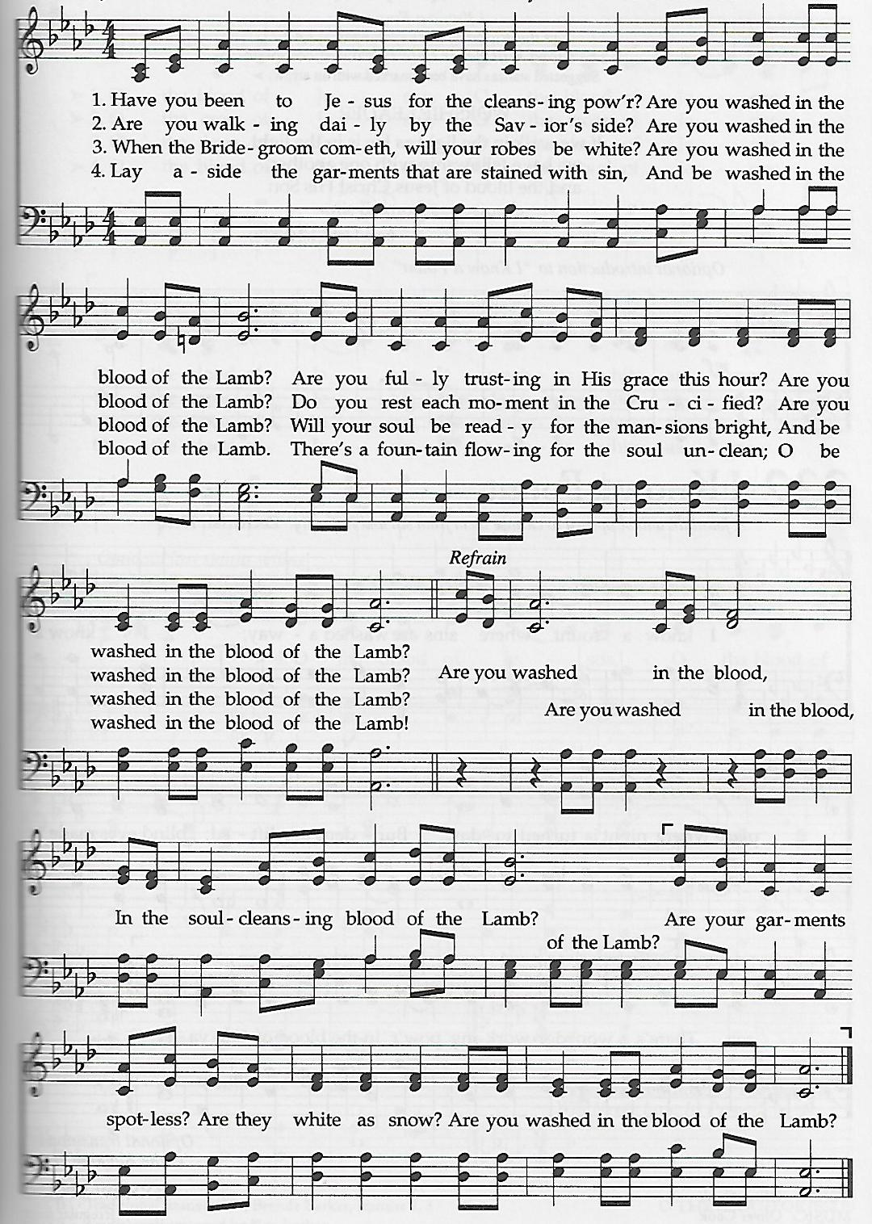
Are You Washed in the Blood?

this week at colington
These opportunities to serve as the Body of Christ are available.
Monday – 2:15pm – MAT at FFES.
Tuesday – 9 am – Prayer Group
1:30pm – Bible Study
Wednesday – 10am – Knitters and crocheters.
1:45 - Volunteers to Beach Food Pantry.
5:30pm – Bible study.
Friday – 7:30am – Student of the month at FFES.

coming up
Next Sunday – 8:15 – choir practice
9:30 am – Palm Sunday Worship, in-person and Facebook Live followed by a manna meal. Sign-up sheet on counter in fellowship room.
Tues., March 31 - 1:30pm – Bible study.
Wed., April 1 – 5:30pm – Bible study.
Thanks to today’s volunteers!
Ushers – Steve Knowles/ Ozzie Gray
Scripture Reader – Pat Hansen
Communion Assistant – Ozzie Gray

The flowers on the altar are given to the Glory of God.
Last week’s attendance – 86.

